10/30/2022

DevOps

Assignment 01

***Submitted to:***

**Mr. Qasim Malik**

***Submitted by:***

**Khadija Tuz Zehra**

**FA19-BCS-033**

Contents

**Create a new instance** 2

**Connect to VM with PuTTY** 3

**Installing Apache server** 3

**Install MySQL** 4

**Install phpMyAdmin database** 5

**Install PHP** 6

**Clone GitHub project** 6

**Deployment** 8

**URL** 8

***Part 2*** 9

**Create Elastic Beanstalk instance** 9

**Connect to Elastic Beans** 12

**Create DB** 13

**Configure .env file** 14

**URL – part 02** 15

# **Create a new instance**

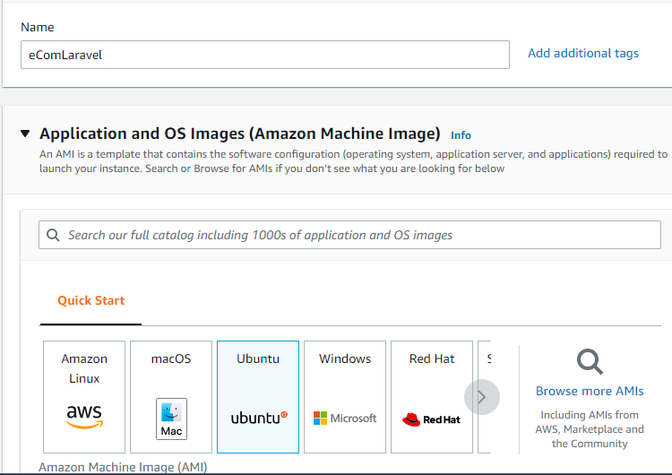

Figure 1: Name the instance, and specify the OS to be installed

Figure 2: Generate a key, to connect to VM from local system

Define the following security inbound rules:

Figure 3: Allow SSH traffic (to connect to instance) and allow HTTP traffic

Figure 4: New instance created

**

Figure 5: add Public IPv4 address Figure 6: Add your .ppk file (key)

# **Installing Apache server**

Run the following commands beforehand,

* sudo apt-get update
* sudo apt-get upgrade

Installing zip unzip extension

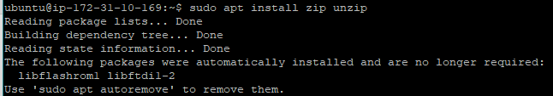

Figure 7: Install zip unzip extension

Install apache2

Figure 8: Install apache2 server

Check if apache2 is running:

Figure 9: apache2 server is installed and running

Access public IPv4 DNS address to confirm Apache server installation

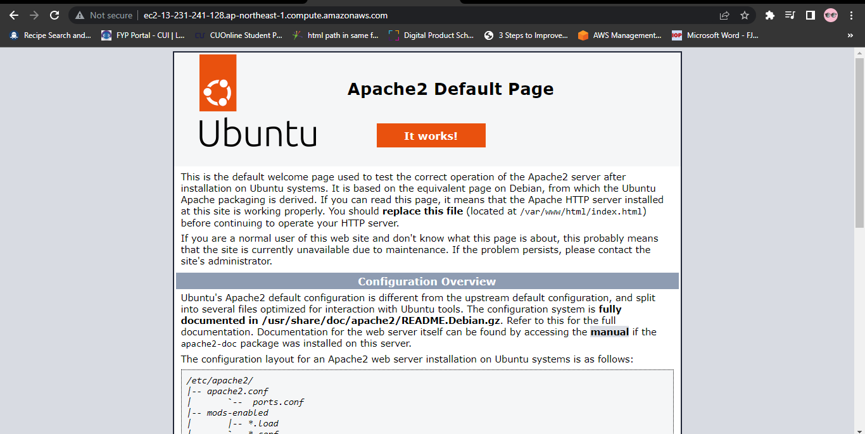

Figure 10: The following page response confirms Apache server installation on ubuntu:

# **Install MySQL**

Run the following commands to install MySQL server:

Figure 11: install MySQL server

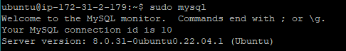

Figure 12: Switch to MySQL terminal to set password

Figure 13: Create password for root user

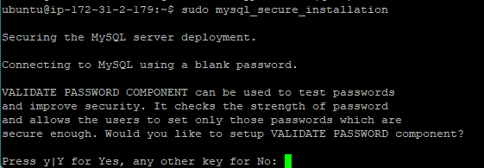

Figure 14: Install MySQL secure server

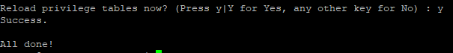

Figure 15: Configure the MySQL server

# **Install phpMyAdmin database**



Figure 15: Install phpMyAdmin database

Open the following file and edit:



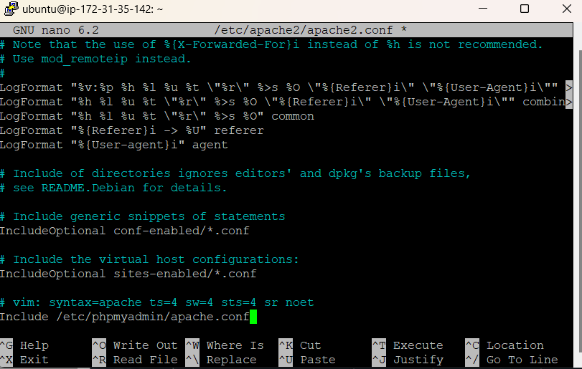

Figure 16 and 17: Add ***“Include /etc/phpMyAdmin/apache.conf”***



Figure 18: Restart your Apache server

Figure 19: access phpMyAdmin by URL: ***IP-address/phpMyAdmin/index.php***

Login to phpMyAdmin:

Figure 20: Login to phpMyAdmin with valid credentials

# **Install PHP**



Figure 21: Run the following command to install PHP

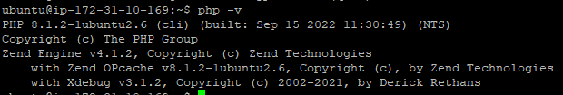

Figure 22: Check your php installed version

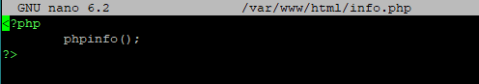

Figure 23: Add following lines to /var/www/html/info.php

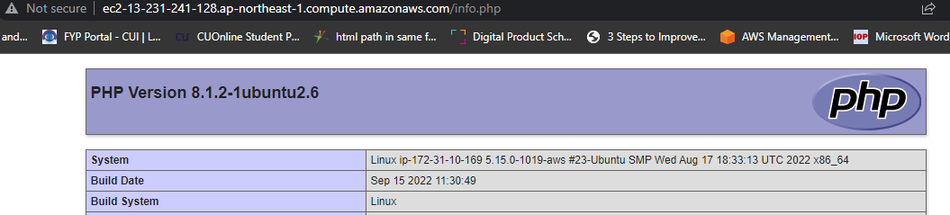

Figure 24: Accessing the following URL Confirms PHP installation:

# **Clone GitHub project**

Add code from GitHub to local repository, clone your project from GitHub

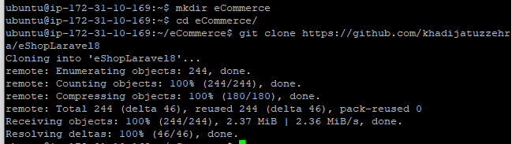

Figure 25: Create a new directory and clone project from GitHub repo

Install composer:



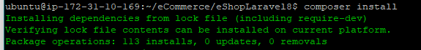

Figure 26 and 27: Install composer by following commands



Figure 28: Copy .env.example to .env

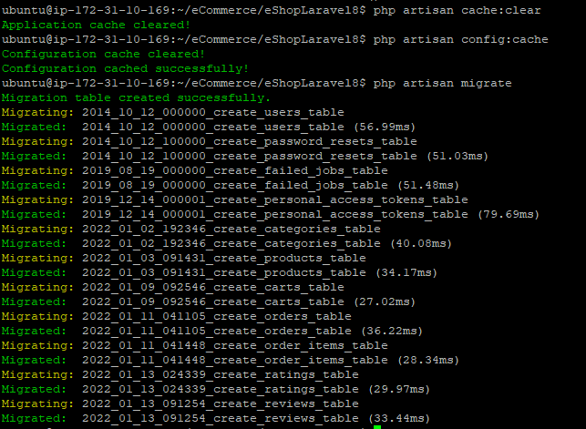

Figure 29: Migrate all tables to database

# **Deployment**

To start Laravel Project, run the following commands

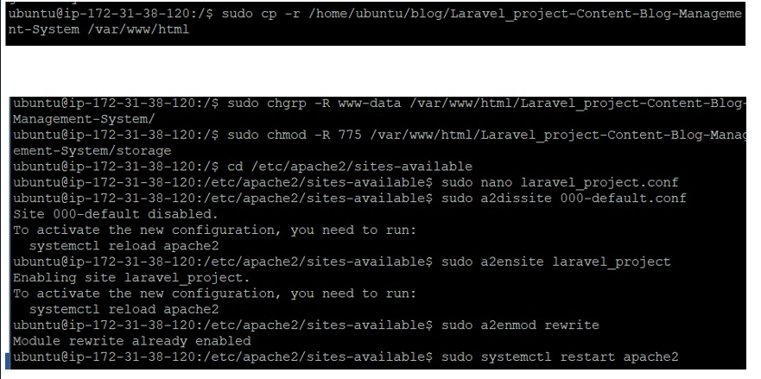

# **URL**

[**http://ec2-13-231-241-128.ap-northeast-1.compute.amazonaws.com/**](http://ec2-13-231-241-128.ap-northeast-1.compute.amazonaws.com/)

# **Part 2**

# **Create Elastic Beanstalk instance**

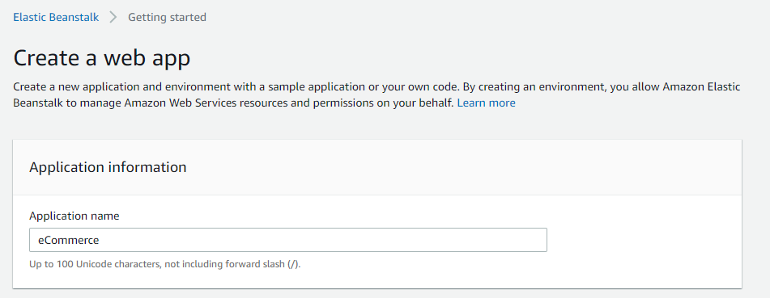

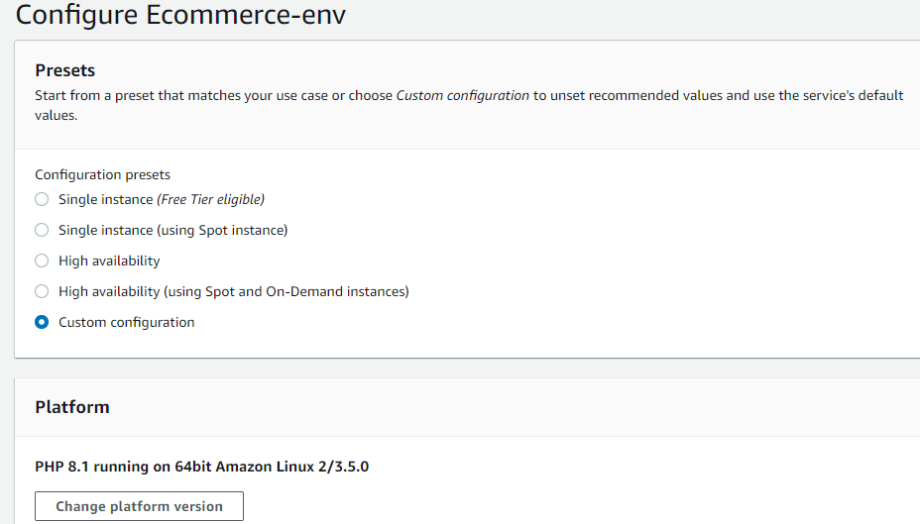

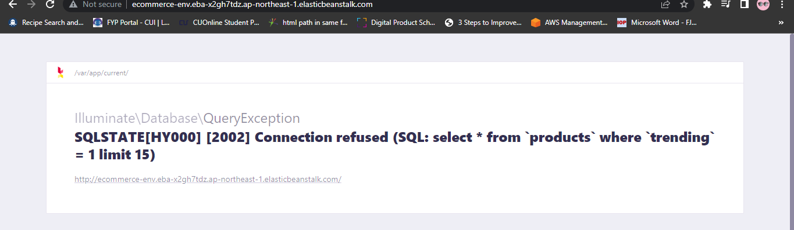

# **Connect to Elastic Beans**

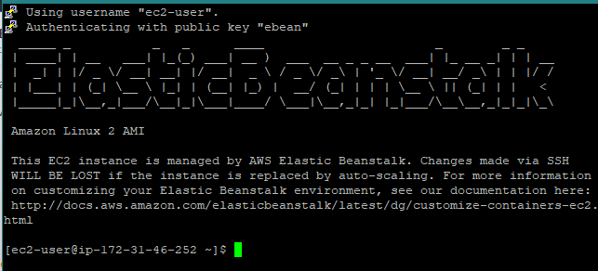

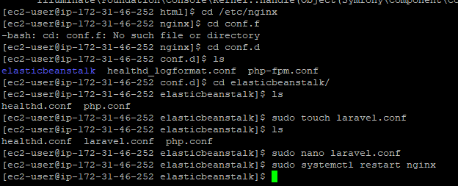

# **Create DB**

# **Configure .env file**

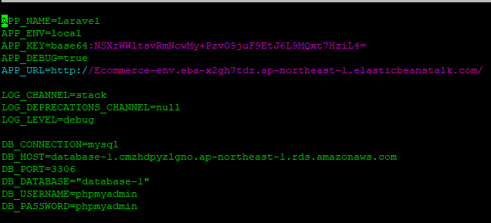



# **URL – part 02**

[**http://ecommerce-env.eba-x2gh7tdz.ap-northeast-1.elasticbeanstalk.com**](http://ecommerce-env.eba-x2gh7tdz.ap-northeast-1.elasticbeanstalk.com/n)